
Symbiosis Institute of Technology, Pune
Faculty of Engineering
CSE- Academic Year 2026-27
Java Programming – Lab Batch 2024-28
Lab Assignment No:- 15
Name of Student: Sanika Botre
PRN No.: 25070122063
Batch: 2025-29
Class: CSE A-2
Academic Year & Semester: 2026 & 3rd Semester
Date of Submission
Title of Assignment: Write a Java program to demonstrate exception handling using finally, throw, and throws.

Learning Objectives: To implement finally, throw, and throws for effective exception management.

Theory: The finally block always executes regardless of whether an exception occurs, making it suitable for resource cleanup. The throw keyword explicitly generates an exception, while throws declares exceptions that a method may pass to its caller. These mechanisms improve structured error handling and application stability.
Practice questions:
1. Create a Login program that throws an exception for invalid password and uses finally block.
Code:
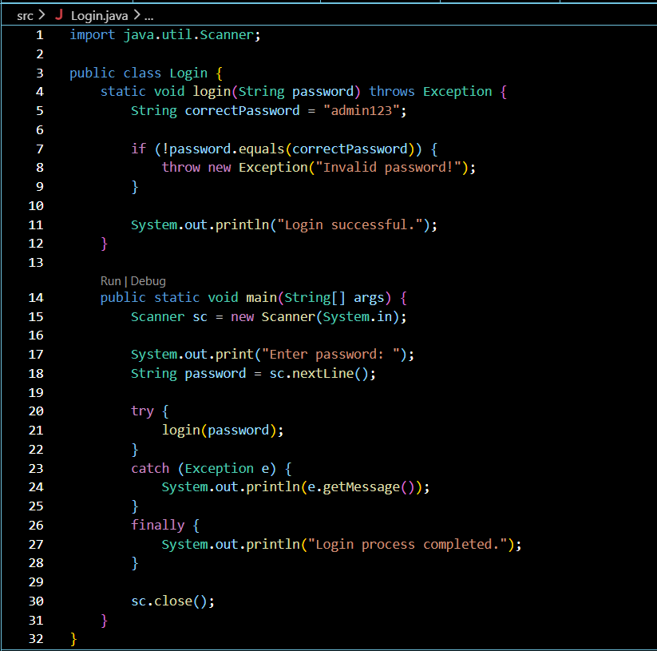

Output:

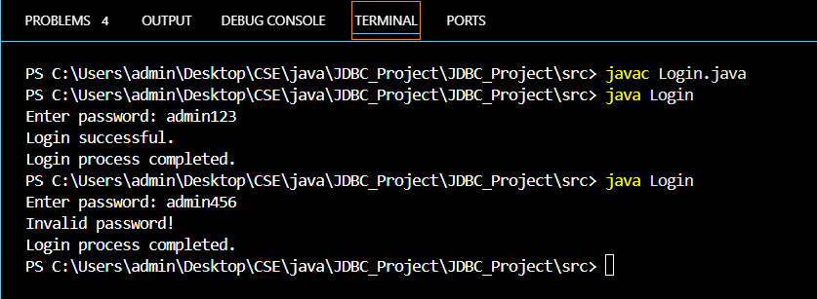

2. Create an ATM PIN Verification program that throws an exception for an invalid PIN entered by the user and uses a finally block to display a message indicating that the verification process has completed.
Code:
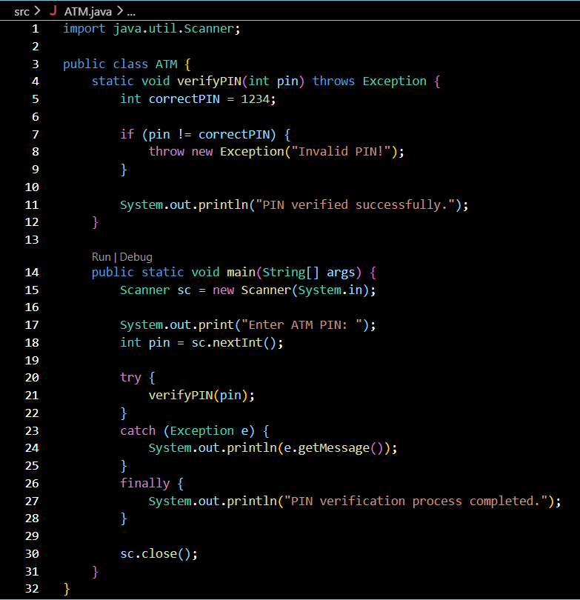

Output:
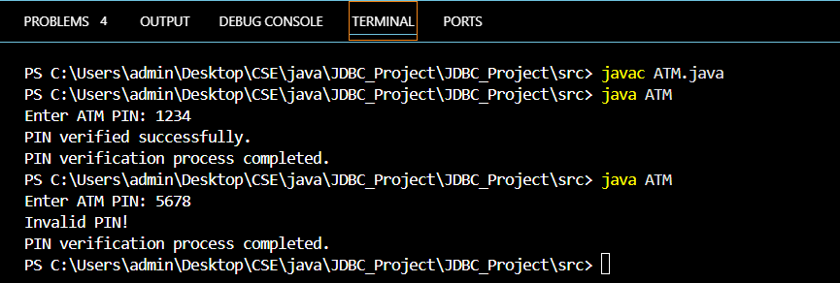
Conclusion:
Thus, the Login Program and ATM PIN Verification Program were successfully implemented using Java exception-handling concepts. The programs demonstrated the use of throw, throws, try-catch, and finally to handle invalid inputs and exceptions. The finally block was executed in both valid and invalid cases, demonstrating that it executes regardless of whether an exception occurs.

